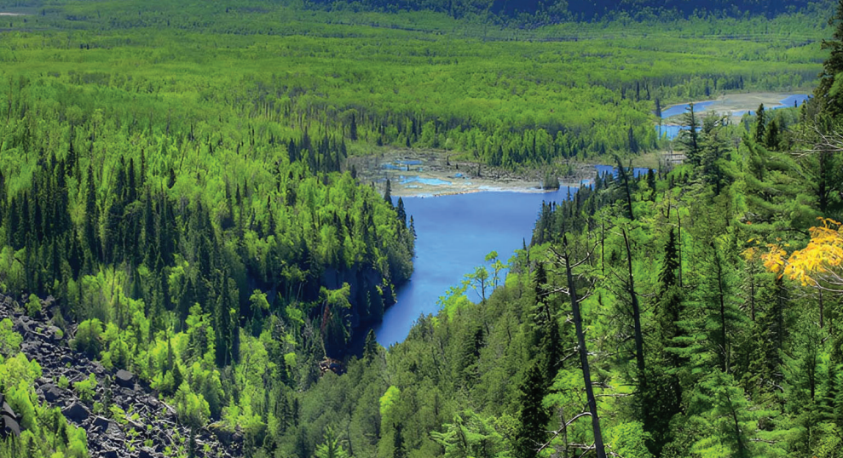SAVING THE BOREAL FOREST.
Animated Video Script
SCENE 01 0:00 to 0:16
COLD OPEN: A SPRING WITHOUT VOICES
VISUALS | Black screen. The sound of a dawn chorus fades up: warblers, loons, a woodpecker. Slow fade into a misty boreal forest at first light, spruce and fir silhouetted against a pale sky. Birdsong thins out one voice at a time until only wind remains. A vintage typewriter types Carson's line on screen, then a 1962 first-edition Silent Spring cover slides in beside it.
TEXT ON SCREEN | "There was a strange stillness... It was a spring without voices."  Rachel Carson, Silent Spring (1962)
NARRATION | There was a strange stillness. A spring without voices. In 1962, Rachel Carson opened Silent Spring with that warning. Today, a new silence is creeping across North America's great northern forest. This time, the trail leads to our bathrooms.  39 words
SCENE 02 0:16 to 0:24
TITLE
VISUALS | Sweeping aerial drone move over a vast green boreal valley, a river cutting through dense conifers (match the report cover landscape). A single roll of white toilet paper drops into frame in the foreground and unrolls across the landscape like a road. Title resolves over the forest in the report's deep green.
TEXT ON SCREEN | SAVING THE BOREAL FOREST  Protecting North America's Boreal Forests from Deforestation for Single-Use Tissue Products
NARRATION | This is the story of the boreal forest, and the toilet paper that is taking it apart, one roll at a time.  22 words
ANIMATOR REFERENCE (from the report)
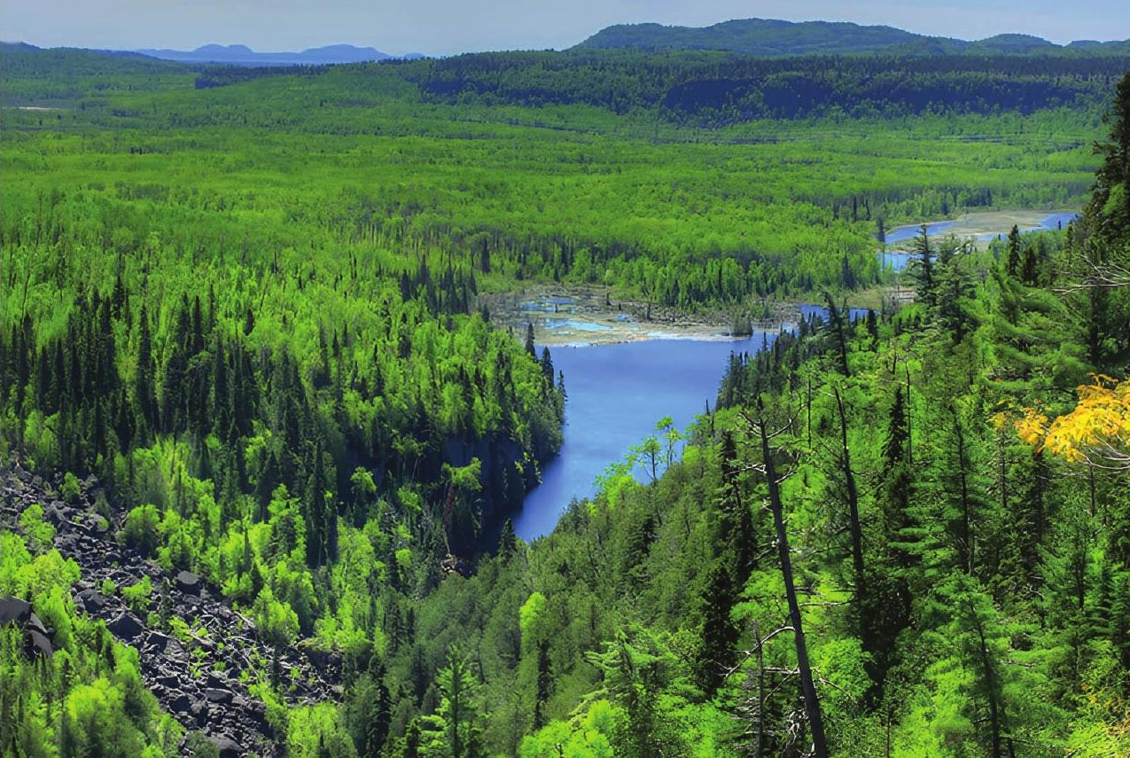
Report cover landscape. Use as the look and colour reference for the hero boreal shots.
SCENE 03 0:24 to 0:39
THE WORLD'S LARGEST INTACT FOREST
VISUALS | Satellite view of North America. The camera pushes in over Canada as the boreal zone traces itself in glowing yellow, exactly as on the report map, wrapping from Alaska and the Yukon across to Labrador. A counter ticks up beside the shape. Ends on a stylised pair of lungs formed by the forest outline, gently breathing.
TEXT ON SCREEN | - World's largest intact forest  - Approx. 30% of the world's forested area  - 1.2 BILLION ACRES in Canada (over 50% of the country)
NARRATION | Stretching across Canada, the boreal is the world's largest intact forest: about 30 percent of Earth's forested land, and over half of Canada. Alongside the tropical rainforests, it is one of the lungs of the Earth.  36 words
ANIMATOR REFERENCE (from the report)
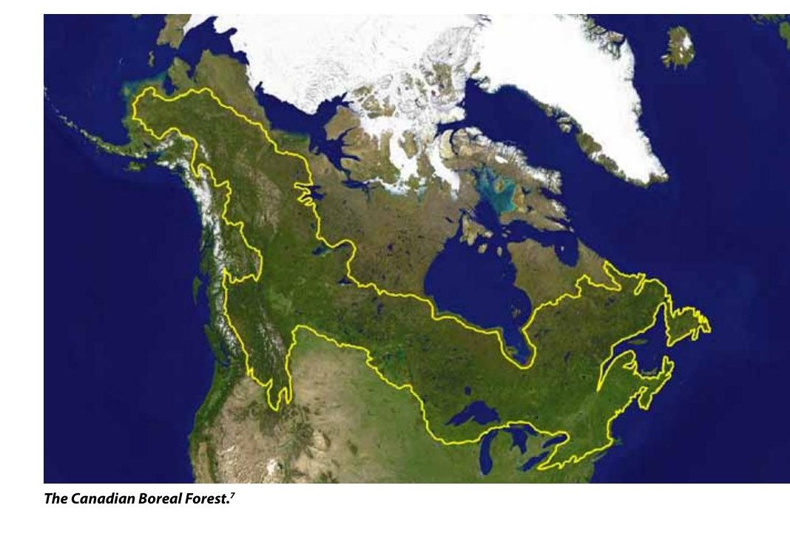
The Canadian Boreal Forest map from the report. Trace this yellow outline for the boreal zone.
SCENE 04 0:39 to 0:52
WHAT THE BOREAL HOLDS
VISUALS | Three animated stat cards slide in over forest footage. Card 1: a wetland and lake network glistening from above, a globe icon a quarter filled with water. Card 2: a split globe comparing the boreal with the Amazon, the boreal side slightly larger. Card 3: two side-by-side acre plots, one boreal and one tropical, carbon bars rising, the boreal bar reaching twice as high.
TEXT ON SCREEN | - 1/4 of the world's wetlands  - 1/4 of the world's remaining intact forest (more than the Amazon)  - 2x the carbon per acre of tropical rainforests
NARRATION | It holds a quarter of the world's wetlands and a quarter of its remaining intact forest, more than the Amazon. Acre for acre, it stores twice as much carbon as a tropical rainforest.  33 words
SCENE 05 0:52 to 1:09
THE CARBON BENEATH OUR FEET
VISUALS | Cross-section cutaway of the forest floor: moss, roots, dark peat, then a frozen permafrost layer below, all glowing with carbon particles. A logging machine rolls across the surface and the cutaway cracks. Methane bubbles (orange) rise out of the peat, three times as many as before. Pull back to a globe: the Arctic glows red and pulses at twice the speed of the rest of the planet.
TEXT ON SCREEN | At least 32% of global land carbon stored in boreal soils, peat and permafrost  - Disturbed peatlands: up to 3x the methane  - Methane: 27x the warming power of CO2  - Arctic warming: 2x the global average
NARRATION | Most of that carbon lives underground, in soil, peat and permafrost: at least 32 percent of the planet's land-based carbon. Disturbed peatlands can release triple the methane. Thawing permafrost releases it too, in a region warming twice as fast as the global average.  43 words
SCENE 06 1:09 to 1:25
THE REPLANTING MYTH
VISUALS | A glossy industry-style billboard reads WE REPLANT EVERY TREE beside a clear-cut. Pan from a towering old-growth spruce to a row of knee-high seedlings in a bare cut block. A carbon meter above each: the old tree's is full, the seedlings' nearly empty. A timeline bar stretches across the screen from 0 to 100+ years, with a human silhouette ageing from child to elder as it fills.
TEXT ON SCREEN | Undisturbed boreal stores 72% MORE CARBON than replanted forest  Carbon payback: well over 100 years
NARRATION | The logging industry promises to replant. Yet undisturbed boreal stores 72 percent more carbon than replanted forest, and mature trees can take well over a century to repay their carbon debt. That is time the climate does not have.  39 words
SCENE 07 1:25 to 1:40
NORTH AMERICA'S BIRD NURSERY
VISUALS | Close, lush shots of nesting birds in the boreal canopy. Name tags pop on as each species appears: Whooping Crane wading a wetland, Great Gray Owl on a snag, Rusty Blackbird, Boreal Chickadee (match the report photo). Pull out to a map of North America at dusk: thousands of glowing bird trails stream south from the boreal into backyards across the United States.
TEXT ON SCREEN | 300+ bird species breed here  Up to 5 BILLION migratory birds fly south each year
NARRATION | The boreal is also North America's bird nursery. More than 300 species breed here, from the Whooping Crane to the Great Gray Owl and Boreal Chickadee. Up to five billion migratory birds fly south from it every year.  38 words
ANIMATOR REFERENCE (from the report)
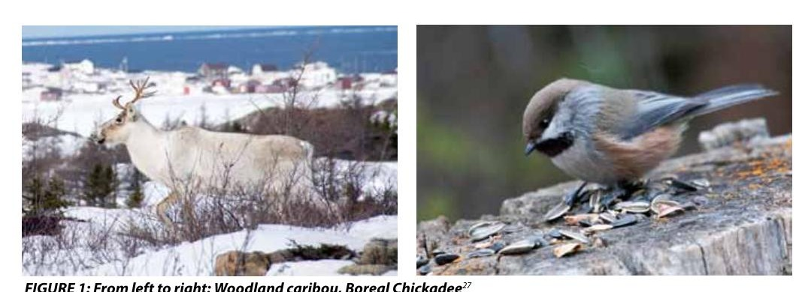
Figure 1 from the report: woodland caribou (left) and Boreal Chickadee (right). Character reference for both animals.
SCENE 08 1:40 to 1:53
A CHAIN REACTION
VISUALS | Animate the report's Figure 2 as a five-step chain, each panel in the same pale green with dark green arrows. 1: an old-growth stand falls to a clear-cut. 2: small deciduous shrubs sprout in the gap. 3: moose arrive to browse. 4: wolf numbers grow, paw prints multiplying. 5: a wolf pack closes in on a lone woodland caribou in snow. Fade the caribou out on the last beat.
TEXT ON SCREEN | 85 mammal species | 32,000+ insect species  CLEAR-CUT > SHRUBS > MOOSE > WOLVES > CARIBOU AT RISK
NARRATION | Clear-cut an old-growth stand and the effects ripple outward. Shrubs move in. Moose follow the food. Wolves follow the moose. And the woodland caribou, a survivor of two million years, becomes the prey.  33 words
ANIMATOR REFERENCE (from the report)
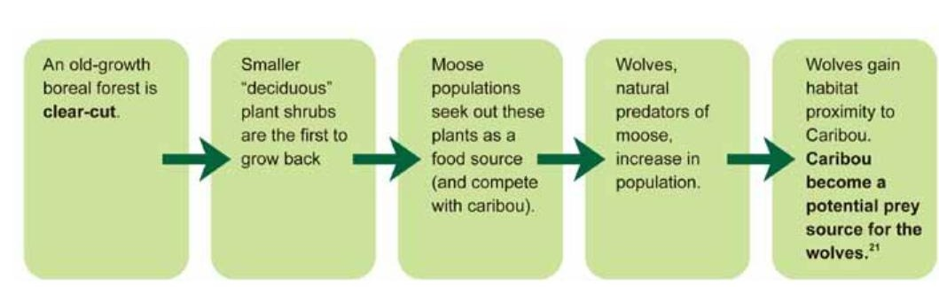
Figure 2 from the report: the clear-cut to caribou chain of consequences. Animate these five boxes in order.
SCENE 09 1:53 to 2:08
GUARDIANS OF THE LAND
VISUALS | Warm, respectful sequence: Indigenous Guardians in a canoe on a calm boreal lake, checking a trail camera, mapping on a tablet beside elders. A map of Canada shows protected-area boundaries filling in with soft gold, labelled Edéhzhíe and Thaidene Nëné. A simple coin graphic: one coin in, twenty coins out.
TEXT ON SCREEN | - ~600 Indigenous communities  - Thaidene Nëné: 10,184 sq miles protected  - Guardian programs: up to $20 back for every $1
NARRATION | For thousands of years, around 600 Indigenous communities have stewarded this land. Today they lead its protection, securing vast protected areas like Thaidene Nëné and running Guardian programs that return up to 20 dollars for every dollar invested.  38 words
SCENE 10 2:08 to 2:20
A FOREST UNDER THREAT
VISUALS | Mood shift. Colour drains to cooler tones. The boreal map returns and 30 percent of it turns industrial grey. A year counter spins from 1975 to today as orange cut patches spread across the southern boreal. Heavy machinery, a feller buncher, cuts through a stand. Logs stack on a truck.
TEXT ON SCREEN | - 30% allocated to industry  - 75+ MILLION ACRES logged since 1975  - 1 MILLION+ new acres cleared every year
NARRATION | Yet 30 percent of Canada's boreal is allocated to industry. More than 75 million acres have been logged since 1975, and over a million new acres are cleared every year.  30 words
SCENE 11 2:20 to 2:28
THE SPEED OF LOSS
VISUALS | Split screen. Left: a clock's second hand ticking. Right: a top-down forest where a tennis-court-sized rectangle vanishes every two seconds. Then a stopwatch hits 60 seconds and five hockey rinks drop in as cut-outs where forest stood.
TEXT ON SCREEN | Every minute: 5 hockey rinks of forest  Every 2 seconds: 1 tennis court
NARRATION | Every minute, five hockey rinks' worth of intact forest are clear-cut. Every two seconds, another tennis court of forest disappears.  20 words
SCENE 12 2:28 to 2:42
A PATCHWORK FOREST
VISUALS | Animate the report's Figure 3 map of Quebec and Ontario: blue for forest at least 100 years old, orange for areas logged since 1976. The orange spreads as the years tick. Overlay an outline of Alaska over the commercially managed zone, then outlines of Texas and Colorado together to show the 61% already cut. A thin green sliver highlights the protected share.
TEXT ON SCREEN | - 400 million acres managed for logging (the size of Alaska)  - 61% already clear-cut at least once (bigger than Texas + Colorado)  - Only 8 to 13% formally protected
NARRATION | Of the 400 million acres managed for logging, an area the size of Alaska, 61 percent has already been clear-cut at least once. Only 8 to 13 percent of the boreal is formally protected.  34 words
ANIMATOR REFERENCE (from the report)
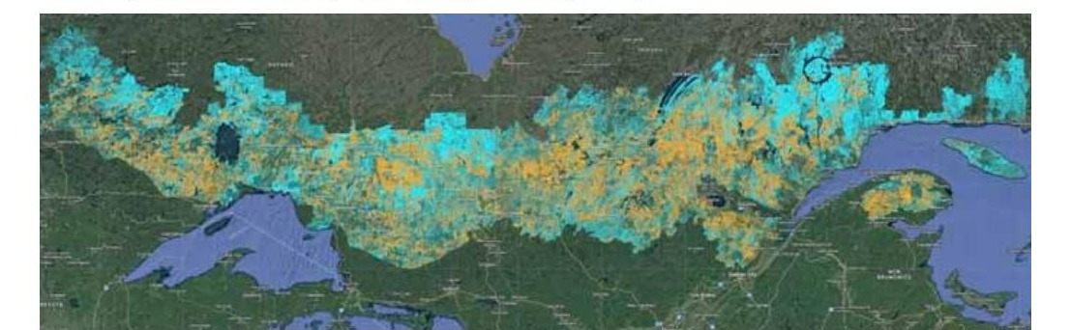
Figure 3 from the report: orange = logged in Quebec and Ontario since 1976, blue = forest at least 100 years old.
SCENE 13 2:42 to 2:49
SCARS FROM ABOVE
VISUALS | Slow aerial drift over Ontario, matching the report's Figure 4: logging roads branching like veins, bare landings, clusters of cut blocks dotting the green. Map pins drop one by one across the area, counting up.
TEXT ON SCREEN | 290+ sites of forest loss mapped in Ontario from roads and landings
NARRATION | From above, the scars are impossible to miss. Roads, landings and clearings carve intact forest into patchwork.  17 words
ANIMATOR REFERENCE (from the report)
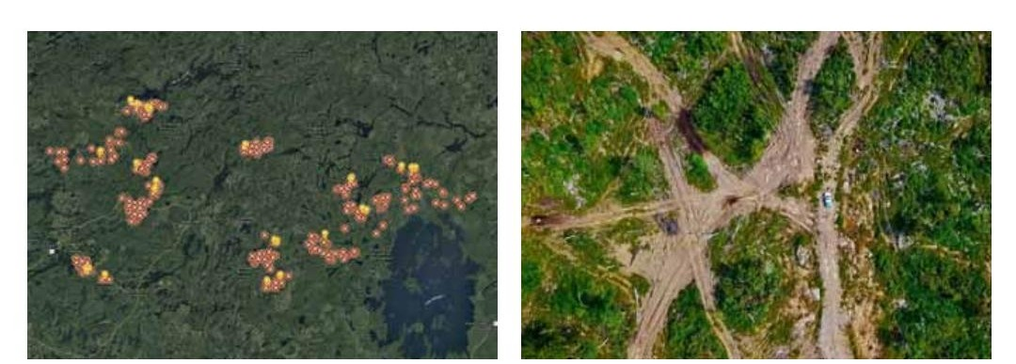
Figure 4 from the report: Wildlands League map of 290+ loss sites (left) and aerial logging scars in Ontario (right).
SCENE 14 2:49 to 3:01
FOLLOW THE WOOD
VISUALS | Animated supply-chain line: logs leave a Canadian mill, split into arrows, and the thickest arrow (two-thirds) crosses the border into the United States. A smokestack icon on Canada's emissions chart rises to third place when logging is added.
TEXT ON SCREEN | - Over half of Canada's forest products are exported  - 2/3 of exports go to the U.S.  - Logging: Canada's 3rd-largest emissions source, if properly counted
NARRATION | Where does it all go? Over half of Canada's forest products are exported, two-thirds of them to the United States. Counted properly, logging would be Canada's third-largest source of emissions.  30 words
SCENE 15 3:01 to 3:14
THE U.S. LEADS THE WORLD
VISUALS | Animate the report's Statista chart: horizontal bars built from stacks of toilet rolls, one country at a time, with the United States bar rolling out longest at 141. Cut to a typical American bathroom: a toilet roll holder spins and spools paper endlessly.
TEXT ON SCREEN | U.S.: up to 141 rolls per person per year  #1 in the world
NARRATION | And much of it ends up in American bathrooms. The United States leads the world in toilet paper use: up to 141 rolls per person a year. Most major brands rely on boreal wood.  34 words
ANIMATOR REFERENCE (from the report)
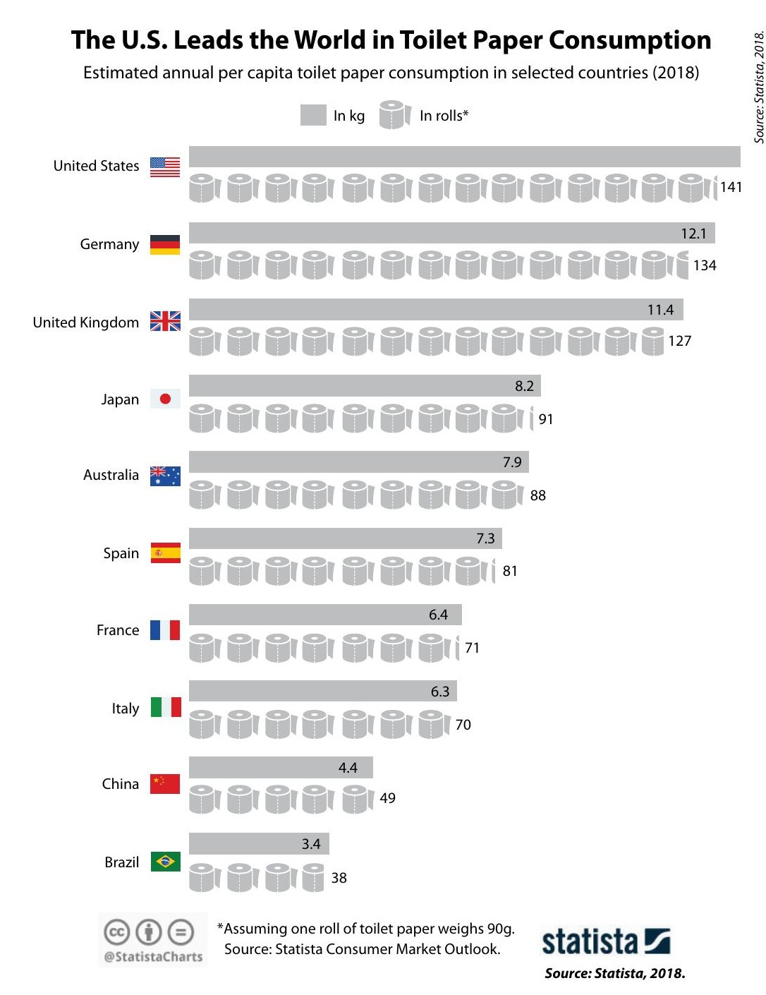
Report chart: annual per-capita toilet paper use by country (Statista, 2018). Rebuild with rolls as bar units.
SCENE 16 3:14 to 3:30
FROM FOREST TO FLUSH
VISUALS | Animate the report's five green infographic tiles in sequence, the tree tile landing last at 31,114,249. One large spruce splits into 1,500 rolls that fan out to a row of ten people. Then a fast match-cut journey: chainsaw in an Ontario clear-cut, pulp mill, truck, store shelf, a New York restroom. A hand tears off a sheet. The roll empties in a second.
TEXT ON SCREEN | - 31.1 MILLION trees a year for U.S. toilet paper  - 1 tree = up to 1,500 rolls = about 10 Americans  - Ontario clear-cut to New York restroom: a few weeks
NARRATION | Supplying it takes 31.1 million trees a year. One large tree makes no more than 1,500 rolls, enough for about 10 Americans. A clear-cut in Ontario reaches a New York restroom in weeks, and is gone in seconds.  38 words
ANIMATOR REFERENCE (from the report)
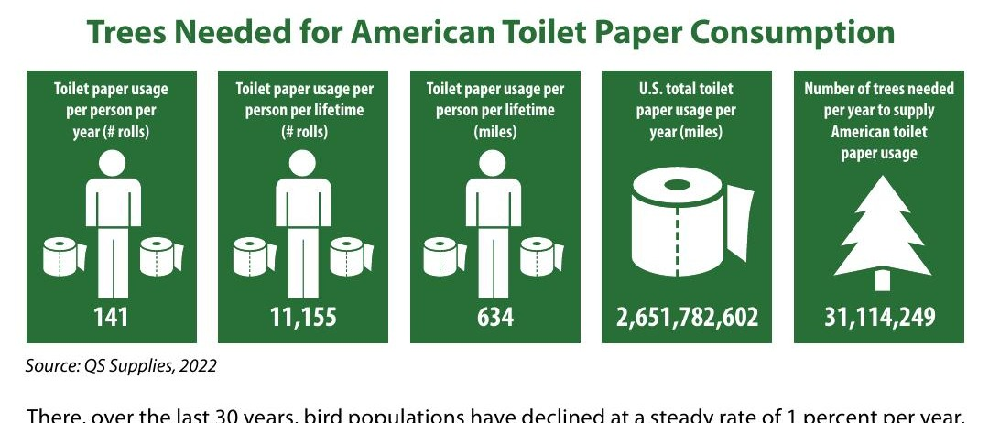
Report infographic: trees needed for American toilet paper consumption (QS Supplies, 2022). Animate these five tiles.
SCENE 17 3:30 to 3:42
A WARNING FROM FINLAND
VISUALS | A quiet Finnish boreal forest. A bird population line graph draws across the sky, dropping steadily over 30 years. Silhouettes of migrating birds on a power line disappear one by one until nearly half are gone.
TEXT ON SCREEN | Finland's southern boreal: birds down 1% a year for 30 years  Long-distance migrants: down 44%
NARRATION | We have already glimpsed where this road leads. In Finland's southern boreal forests, bird populations have fallen one percent a year for 30 years. Long-distance migrants have declined by 44 percent.  31 words
ANIMATOR REFERENCE (from the report)
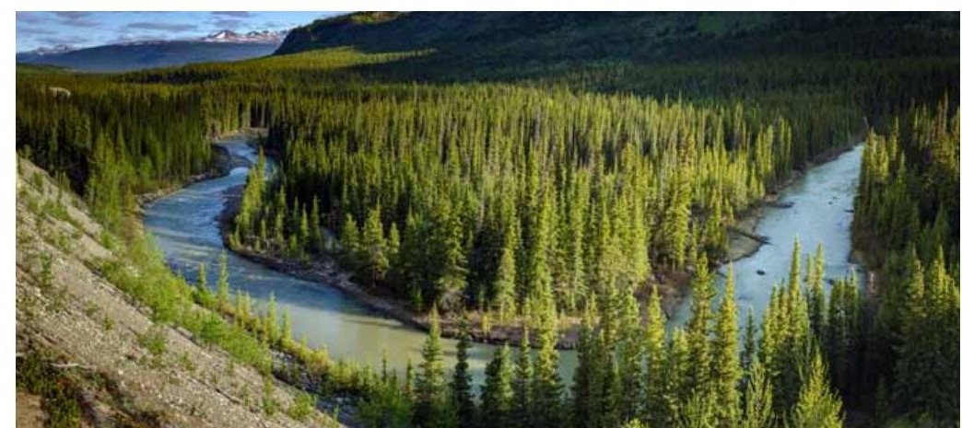
Report photo: Watson River Upper Canyon, northern boreal. Use as the look for intact, untouched forest.
SCENE 18 3:42 to 4:00
BETTER CHOICES ALREADY EXIST
VISUALS | Bright, hopeful palette returns. A bamboo time-lapse shoots up a full meter, gets harvested, and regrows from its roots. Office paper and cardboard tumble into a recycling machine and come out as fresh rolls. Wheat straw sways. A bidet icon pops in. A short bar comparison: Italy, France and Finland at less than half the U.S. bar.
TEXT ON SCREEN | Bamboo: grows up to 1 meter a day, regrows after harvest  Recycled | Alternative fibers | Bidets  Italy, France, Finland use less than half as much as the U.S.
NARRATION | The good news? Alternatives already exist. Bamboo, a grass, can grow a meter a day and regrows after harvest. Recycled tissue turns used paper into new rolls. Bidets cut paper use altogether. Italy, France and Finland already use less than half what Americans do.  44 words
SCENE 19 4:00 to 4:16
WHAT YOU CAN DO
VISUALS | A shopper in a grocery aisle picks up a tissue pack and flips it over. Question bubbles pop up one at a time around the pack. A magnifier finds an FSC logo. The shopper swaps the virgin-wood pack for bamboo. Animate the report's 7-in-10 graphic as figures light up green. Then a phone screen: a short letter to a brand, a share button, a campaign sign-up.
TEXT ON SCREEN | Where does the fiber come from?  Look for FSC certification  7 IN 10 consumers prioritize eco-friendly toilet paper
NARRATION | Change starts at the shelf. Ask where the fiber comes from. Look for FSC certification. Choose bamboo or recycled. Nearly seven in ten consumers already prioritize it. Then use your voice: write to brands, join campaigns, share what you learn.  40 words
ANIMATOR REFERENCE (from the report)
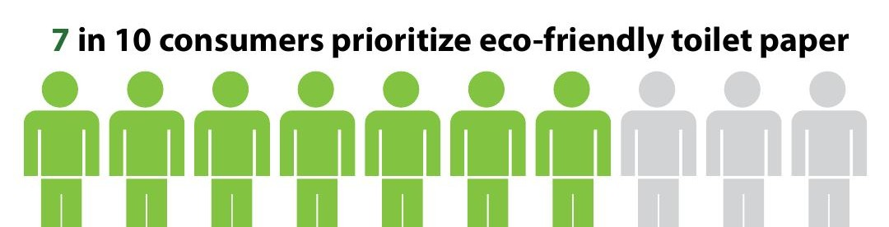
Report graphic: 7 in 10 consumers prioritize eco-friendly toilet paper. Animate figures turning green.
SCENE 20 4:16 to 4:30
FROM CHOICE TO CHANGE
VISUALS | Animate the report's four-step pathway as green blocks joined by arrows, each one growing larger: one person, a crowd, a city, a government building. Then a corporate boardroom screen shows a public target being signed, a store shelf rearranges so bamboo and recycled packs sit at eye level, and an auditor's stamp lands on a supply-chain document.
TEXT ON SCREEN | EDUCATION > INDIVIDUAL CHOICE > COLLECTIVE PRESSURE > SYSTEMIC CHANGE  Companies: public dated targets | sustainable by default | independent audits
NARRATION | Education becomes individual choice. Choice becomes collective pressure. Pressure becomes systemic change. Companies can set public, dated targets for recycled and alternative fiber, put sustainable options on standard shelves, and prove their claims with independent audits.  36 words
ANIMATOR REFERENCE (from the report)

Report flowchart: Education to Individual consumer choice to Collective pressure to Systemic policy change.
SCENE 21 4:30 to 4:39
WHAT LEADERS CAN DO
VISUALS | Capitol dome and a Canadian parliament silhouette side by side. Four policy icons stamp down in turn: an emissions gauge, a federal purchasing contract marked BINDING, a cargo container under a scanner at the border, and a migratory bird flying over a map linking Canada and the U.S. with a heart over Indigenous-led protected land.
TEXT ON SCREEN | - Track logging emissions  - Binding buy-recycled rules  - Scrutinize boreal pulp imports  - Fund bird and Indigenous-led conservation
NARRATION | Policymakers can track logging emissions honestly, make federal buy-recycled rules binding, scrutinize boreal pulp imports, and fund cross-border bird and Indigenous-led conservation.  22 words
SCENE 22 4:39 to 4:58
LISTEN BEFORE THE SPRING GOES QUIET
VISUALS | Return to the boreal at dawn. The birdsong from the opening swells back in, voice by voice. A flock lifts off the treetops and heads south, the camera following them across the border into an American backyard where a child looks up at a warbler on a feeder. Final hold on the full, living forest.
TEXT ON SCREEN | The boreal is not yet silent.
NARRATION | The boreal forest is not yet silent. Its dawn chorus still reaches hundreds of millions of American backyards each spring. As its largest customer, America holds the solution. Will we keep flushing the boreal away, one roll at a time? Or will we listen, before the spring goes quiet?  49 words
ANIMATOR REFERENCE (from the report)
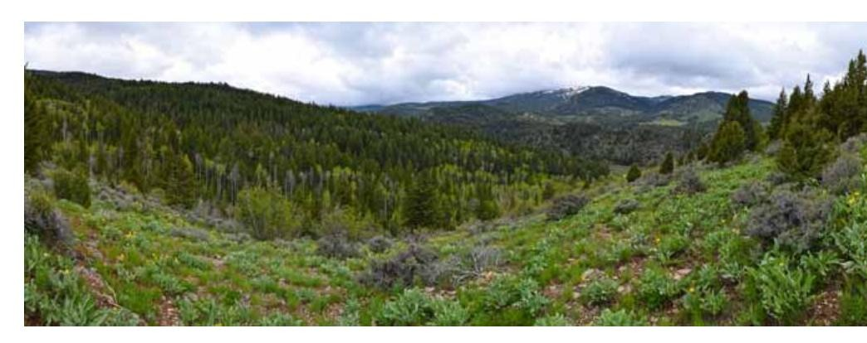
Report closing landscape. Use for the final wide.
SCENE 23 4:58 to 5:03
END CARD
VISUALS | Clean green end card. Rachel Carson Council logo animates in. Call to action and website below.
TEXT ON SCREEN | Choose bamboo or recycled.  Join the campaign.  RACHEL CARSON COUNCIL  rachelcarsoncouncil.org
NARRATION | Join the Rachel Carson Council's campaign to save the boreal forest.  11 words

